To start recording click this icon and select from 4 options, we will use Basic (for notepad, a simple tool) or Desktop (when automating a desktop tool)

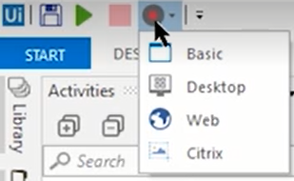

After selecting it will show the following

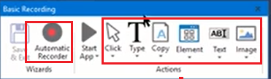

You have to decide which way to follow

* Generate an automation skeleton from everything you will do
* Generate an automation skeleton going step by step

**Usually we will take : Automatic Recorder**

**Once we finish the recording we will press “Escape” and then “Save”, OR CLICK “ESCAPE” twice**

|  |  |
| --- | --- |
| **If we use Automatic Recordable we can record** | **If we don’t use Automatic recordable we can record** |
| **THE MOST COMMON BEHAVIOR**  **Click buttons, checkboxes, dropdows, radio button**  **SET TEXT** | **Keyboard shortcuts**  **Modifier keys**  **Mouse Right click**  **Mouse hover**  **GET TEXT**  **Find Image**  **Copy Paste** |

**If you want to add a new step to the recording**

* **Add the new step manually to the process**
* **Or run the recording and when you get to the step where you want to include something, press F2, wait for a moment and include the new step, then press “ESCAPE” and continue.**

If you want to check the element, not Font but Format, open notepad, select indicate on Screen and point to the NEW ELEMENT, BUT IN THE SAME CONTEINER, in the case Format and Font are in the same conteiner

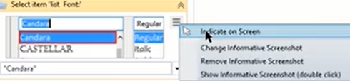

Para escribir primero le dice limpiar, checkbox, y escribe arriba lo que desea, si da check a password no se vera el texto

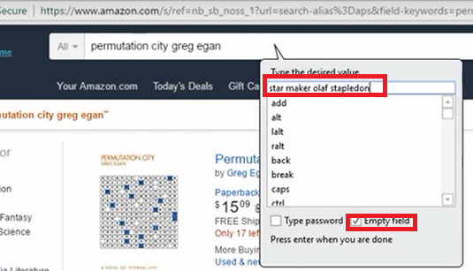

To get a text from a field

ESC F2

